# FA Sharr Award Winner

### ***Monday, 30 May 2016, Canberra:*** Librarian at the University Of Western Australia (UWA), Chloe Czerwiec,has beenawarded the [FA Sharr award.](https://www.alia.org.au/about-alia/awards-and-grants/355/f-sharr-award)

Chloe was presented the award at a ceremony held at the State Library of Western Australia on

Thursday 26 May.

The award is now presented to a Western Australian librarian or library technician within their first three years following graduation, who exhibits the most potential to make a significant contribution to the library profession in WA. The F A Sharr Award is maintained by the [ALIAWest](https://www.alia.org.au/groups/aliawest) Group, with the generous support of the WA Library Technicians Group.

Chloe is the copyright and innovation librarian at UWA. She provides copyright support to the UWA community and her innovation role is at the [Centre for Education Futures](http://www.worldclasseducation.uwa.edu.au/education-futures) which provides information and support to staff to enable education innovation and futures thinking.

Speaking to ALIA, Chloe said being a recipient of the award was a 'tremendous honour.'

When asked why she decided to make a contribution to the profession through the ALIA Students and New Graduates Group in WA, she said: "I always love to attend the ALIA events to share experiences with colleagues, I felt it was an opportunity to give back and it's really energising.'

'I also find there's great opportunities to learn from colleagues - even during the awards event, I had a great exchange with Jessica Madureira, Assistant Library Manager at the City of Swan, who received the Kay Poustie Scholarship to research the topic of *Books vs Space – Collecting Meaningful Statistics to make Better Decisions*.'

Chloe studied at (insert education)

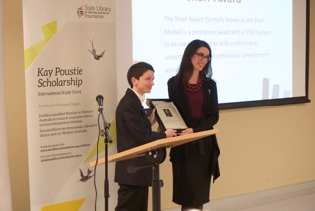

**ENDS**

**About the Australian Library and Information Association**

The Australian Library and Information Association (ALIA) is the professional organisation for the Australian library and information services sector. With 5,000 members across Australia, we provide the national voice of the profession in the development, promotion and delivery of quality library and information services, through leadership, advocacy and mutual support. www.alia.org.au

**Contact:**

Heather Wellard, Communications Manager: [heather.wellard@alia.org.au](mailto:heather.wellard@alia.org.au) | 02 6215 8225 | 0409830 439